**MYSQL QUESTION 1**

**Q. Given table, Tutor, is shown below.**

|  |  |  |  |  |  |
| --- | --- | --- | --- | --- | --- |
| ID | NAME | AGE | CITY | FEE | PHONE |
| P1 | SAMEER | 34 | DELHI | 45000 | 9811076656 |
| P2 | ARYAN | 35 | NAGARKOT | 54000 | 9911343989 |
| P4 | RAM | 34 | CHENNAI | 45000 | 9810593578 |
| P6 | PREMLATA | 36 | BHOPAL | 60000 | 9910139987 |
| P7 | SHIKHA | 36 | RAJKOT | 34000 | 9912139456 |
| P8 | RADHA | 33 | DELHI | 23000 | 8110668888 |

**Write commands to do the following:**

1. Display the name of those students in descending order whose age doesn’t lie between 35 and 40.

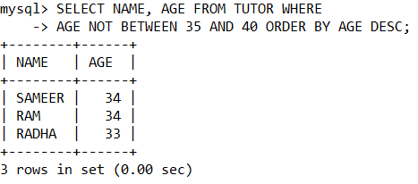

1. List cities with their average fee in it.

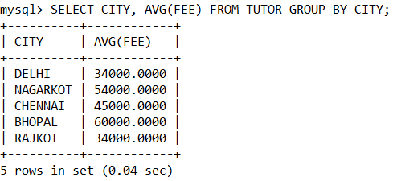

1. Decrease the fees of Shikha by 5%.

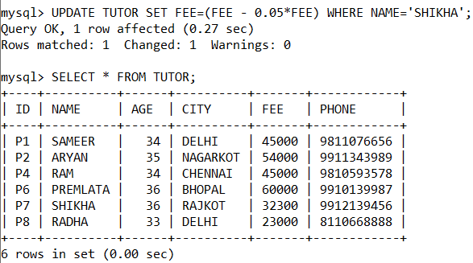



1. Display cities where fees are maximum and minimum respectively.

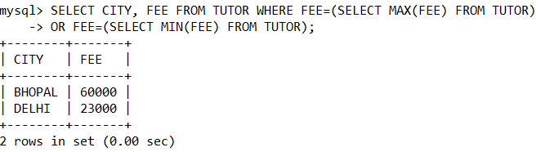

1. Display the name and city of tutor who lives in a city having ‘O’ but not ‘P’.

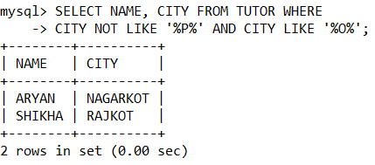

**MYSQL QUESTION 2**

**Q. Consider the following tables, WATCHES and SALES, and write the SQL commands for subparts (i) to (v):**

|  |  |  |  |  |
| --- | --- | --- | --- | --- |
| WatchId | Watch_Name | Price | Type | Qty_Store |
| W001 | High Time | 10000 | Unisex | 100 |
| W002 | Life Time | 15000 | Ladies | 150 |
| W003 | Wave | 20000 | Gents | 200 |
| W004 | High Fashion | 7000 | Unisex | 250 |
| W005 | Golden Time | 2500 | Gents | 100 |

WATCHES

|  |  |  |
| --- | --- | --- |
| WatchId | Qty_Sold | Quarter |
| W001 | 10 | 1 |
| W003 | 5 | 1 |
| W002 | 20 | 2 |
| W003 | 10 | 2 |
| W001 | 15 | 3 |
| W002 | 20 | 3 |
| W005 | 10 | 3 |
| W003 | 15 | 4 |

SALES

1. To display watch name and their quantity sold in first quarter.

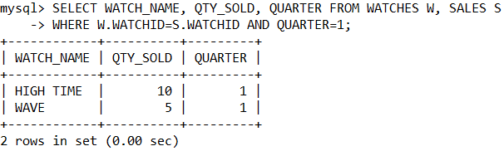

1. To display the details of those watches whose name ends with ‘Time’.

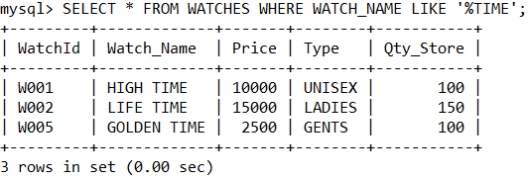

1. To display total quantity in store of Unisex type watches.

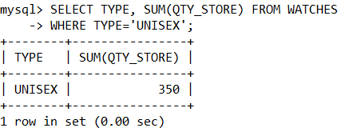

1. To display watch’s name and price of those watches which have price range in between 5000-15000.

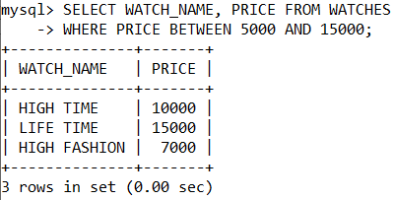

1. To display Quantity sold of all watches WatchId wise.

